1 – 3 – Practice with Composition of functions
1. Let $f\left(x\right)=2x+1$ and $g\left(x\right)=\frac{x-1}{3x+1}$ .
a. If I ask for $[f o g](2)$ , the result is a CIRCLE ONE: [ number / equation ]. Find it.
b. If I ask for $[f o g](x)$, the result is a CIRCLE ONE: [ number / equation ]. Find it.

2. If $f\left(x\right)=5x-2$ and $g\left(x\right)=\frac{x+1}{x}$ What is $g\left(1+f\left(2x\right)\right) ?$
3.
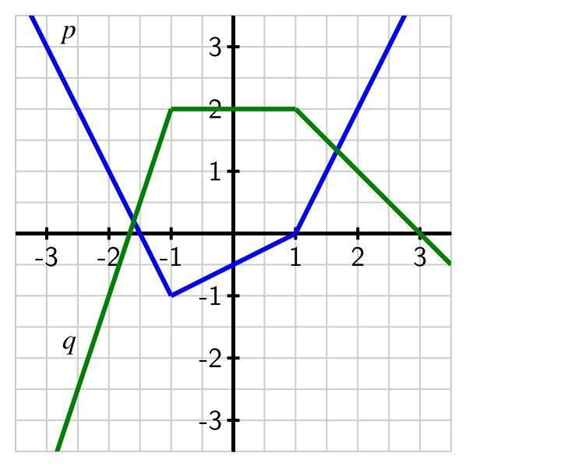
a. What is $[q o p](2)$ ?
b. What is $p\left(p\left(p\left(-2\right)\right)\right)$ ?

4. If $f\left(x\right)=2x-k$ and $f\left(f\left(2\right)-1\right)=7$ what is k?

5. For each function h, find functions f and g so that $h\left(x\right)=f\left(g\left(x\right)\right)$
a). $h\left(x\right)=\sin^{2}\left(x\right)+3\sin\left(x\right)+5$ [note: $\sin^{2}{(x)}$ is the same as ${\left(\sin\left(x\right)\right)}^{2}$ ]
b). $h\left(x\right)=\frac{1}{2^{x+5}}+\frac{1}{2^{x+5} - 1}$
c). $h\left(x\right)={\left(\sqrt{1-x}\right)}^{3}$ There are two slightly different answers for this one.

6. The idea in #5 can help you think more clearly, sometimes.
Consider: $h(x)={\left(x^{2}+7\right)}^{3}$ . What if we want to know the range of $h(x)$?
First, split it into an outer and an inner function: $h\left(x\right)=f\left(g\left(x\right)\right)$. Ask: what’s the smallest and largest thing g(x) could ever be? Then use that to figure out the range of h.

7. If $f(x)$ is a linear function and $g(x)$ is a linear function, is $f(g\left(x\right))$ ALWAYS / SOMETIMES / or NEVER linear? Explain.

1 – 3 – Practice with Composition of functions – Solutions
1. Let $f\left(x\right)=2x+1$ and $g\left(x\right)=\frac{x-1}{3x+1}$ .
a. If I ask for $[f o g](2)$ , the result is a number. It’s $f\left(g\left(2\right)\right)$. $g\left(2\right)→\frac{1}{7}$ , then $f\left(\frac{1}{7}\right)→\frac{2}{7}+1$ or $\frac{16}{7}$
b. If I ask for $[f o g](x)$, the result is an equation. It’s what you get when you substitute the g(x) equation in for x in the f(x) equation. $2⋅g\left(x\right)+1$ $f\left(g\left(x\right)\right)=2⋅\frac{x-1}{3x+1}+1$


2. If $f\left(x\right)=5x-2$ and $g\left(x\right)=\frac{x+1}{x}$ What is $g\left(1+f\left(2x\right)\right) ?$
$f\left(2x\right)=8x+1$.
So: $g\left(1+8x+1\right)→g\left(8x+2\right)→\frac{\left(8x+2\right)-1}{3\left(8x+2\right)+1}→\frac{8x + 1}{24x + 7}$

3.
a. What is $[q o p](2)$ ? $q\left(p\left(2\right)\right)$. $p\left(2\right)=2$. $q\left(2\right)=1$
b. What is $p\left(p\left(p\left(-2\right)\right)\right)$ $p\left(-2\right)=1$. $p\left(1\right)=0$. $p\left(0\right)=-\frac{1}{2}$

4. If $f\left(x\right)=2x-k$ and $f\left(f\left(2\right)-1\right)=7$ what is k?
Let’s think about this from the inside out.
We’ll start by simplifying the inside of $f\left(f\left(2\right)-1\right)=7$. Working from the inside, we know that $f\left(2\right)=4-k$.
So $f\left(f\left(2\right)-1\right)$ is $f\left(4-k-1\right)$ which simplifes to $f\left(3-k\right)$, (which is still equal to 7). Let’s keep simplifying:
$f\left(3-k\right)=7$ $2\left(3-k\right)-k=7$ $6-3k=7$
$-1=3k$ $k=-\frac{1}{3}$

4. For each function h, find functions f and g so that $h\left(x\right)=f\left(g\left(x\right)\right)$
a). $h\left(x\right)=\sin^{2}\left(x\right)+3\sin\left(x\right)+5$ $f\left(x\right)=x^{2}+3x+5$ $g\left(x\right)=sin⁡(x)$
b). $h\left(x\right)=\frac{1}{2^{x+5}}+\frac{1}{2^{x+5} - 1}$ $f\left(x\right)=\frac{1}{x}+\frac{1}{x-1}$ $g\left(x\right)=2^{x+5}$
c). $h\left(x\right)={\left(\sqrt{1-x}\right)}^{3}$ Answer 1: $f\left(x\right)=x^{3}$ $g\left(x\right)=\sqrt{1-x}$
Answer 2: $f\left(x\right)={\left(\sqrt{x}\right)}^{3}$ $g\left(x\right)=1-x$

5. Consider: $h(x)={\left(x^{2}+7\right)}^{3}$ . What if we want to know the range of $h(x)$?
Think of h(x) as: $h\left(x\right)={\left(g\left(x\right)\right)}^{3}$ where $g\left(x\right)=x^{2}+7$. $g(x)$ is an upward parabola shifted up by 7. SO the range of $g(x)$ is $y≥7$.
That means smallest input to the cube expression is 7, meaning we can never have an output smaller than $7^{3}$, or 343.
So the range of $h(x)$ is $y≥343$.

6. If $f(x)$ is a linear function and $g(x)$ is a linear function, is $f(g\left(x\right))$ ALWAYS / SOMETIMES / or NEVER linear? Explain.
Always linear. If you want to think with an example: $f\left(x\right)=2x+1$ and $g\left(x\right)=5-x$
$f\left(g\left(x\right)\right)=2\left(5-x\right)+1$ which is linear.
But how do you know that a different example would come out differently?
You might be able to see in your mind that no matter what linear functions you choose, you’ll replace x in one equation with the other equation, which also just has a single power of x.
You can show this in general by using two general linear function:
$f\left(x\right)=ax+b$ and $g\left(x\right)=cx+d$
If you do the calculation with these, you get:
$$f\left(g\left(x\right)\right)=a\left(cx+d\right)+b$$
Is that linear? It has a single power of x, so yes. If you want to ask: what’s the slope and what’s the y-intercept, then you’ll need to simplify it further.
$$f\left(g\left(x\right)\right)=a\left(cx+d\right)+b=ac⋅x+ad+b$$
In this form, you can see the slope of the new function is $ac$ and the y-intercept is $(ad+b)$

